# Week 6: Deep Learning

This week, we begin our exploration into Deep Learning, including simple neural networks, natural language processing, and computer vision. By the end of this module, you will have the tools needed to understand and identify deep learning based applications.

## Introduction to Deep Learning

As we delve deeper into the realm of machine learning in Week 6, the spotlight intensifies on a transformative paradigm—deep learning. At the core of this revolutionary approach are neural networks, sophisticated algorithms inspired by the intricate architecture of the human brain. The depth and complexity inherent in neural networks endow them with the remarkable ability to automatically learn intricate hierarchical representations from data, making them a driving force behind breakthroughs in various domains.

### Neural Networks

Neural networks derive their name and inspiration from the intricate web of neurons in the human brain. The fundamental building block is the artificial neuron, a computational unit that processes information. These neurons are organized into layers, mimicking the layered structure of the brain. The key to the power of neural networks lies in their depth—deeper networks can capture and represent more complex features and relationships within data.

A Neural Network Playground: <https://playground.tensorflow.org/>

### Layers and Hierarchy

Neural networks are composed of layers, each serving a unique purpose in the learning process. The input layer receives raw data, while hidden layers process this data, learning hierarchical representations of features. The output layer produces the final prediction or classification. The magic happens in the hidden layers, where the network autonomously discovers patterns and features, capturing intricate relationships that might be challenging for traditional machine learning algorithms.

The hierarchical nature of neural networks allows them to automatically learn complex features, recognizing patterns at different levels of abstraction. This capacity is particularly potent in tasks such as image recognition, where features at various scales contribute to the overall understanding of an image. Similarly, in natural language processing, the hierarchical representation enables the network to comprehend the nuanced structure and meaning of language.

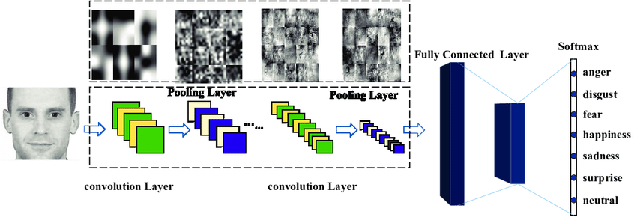

### Activation Functions

Central to the functioning of neural networks are activation functions, which determine the output of each neuron. These functions introduce non-linearities, allowing the network to learn and represent complex relationships in data. Common activation functions include sigmoid, hyperbolic tangent (tanh), and rectified linear unit (ReLU). The non-linear transformations introduced by these functions enable the network to approximate and learn intricate mappings between inputs and outputs.

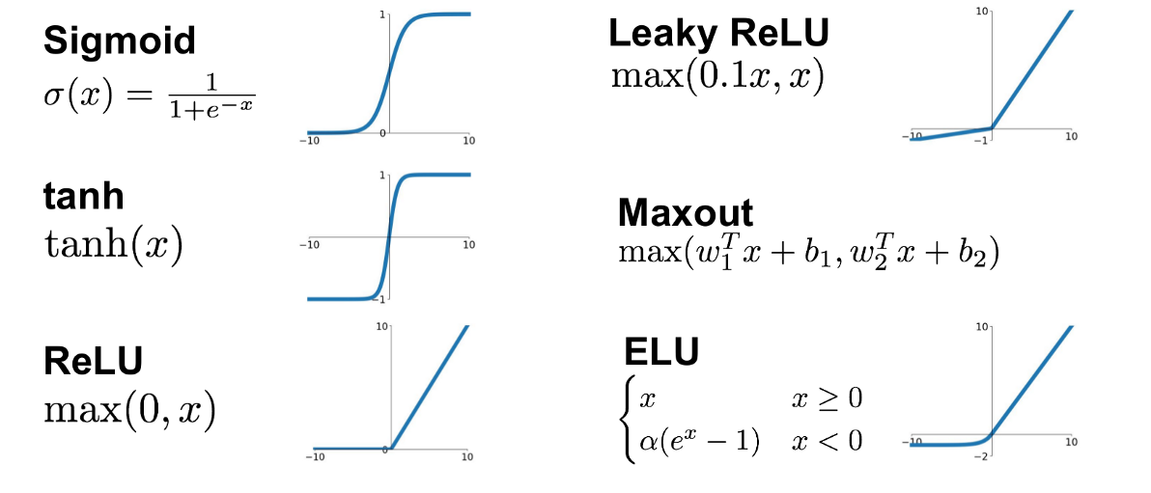

### Applications Across Domains: From Image Recognition to Natural Language Processing

The versatility of deep learning with neural networks is evident in its applications across diverse domains. In image recognition, deep neural networks have achieved remarkable accuracy, surpassing human performance in certain tasks. The ability to automatically learn hierarchical features makes them adept at capturing the nuances in visual data.

In natural language processing, neural networks excel in tasks like sentiment analysis, machine translation, and text generation. The hierarchical representation of language allows the network to understand and generate coherent and contextually relevant text.

## In-Class Activity

* Read through the following article: <https://medium.com/latinxinai/do-you-really-need-deep-learning-84d1a8629ed6>. They suggest that XGBoost may outperform deep learning.
* Play with the resources included in this article for backpropagation: <https://xnought.github.io/backprop-explainer/>

## Convolutional Neural Networks (CNNs)

As we navigate through the intricate landscape of deep learning in Week 6, the focus turns to Convolutional Neural Networks (CNNs), a specialized breed of neural networks tailored for unraveling visual patterns. CNNs represent a groundbreaking advancement, particularly in the realm of computer vision, with their unique architecture designed to address the complexities inherent in tasks like image recognition.

### The Anatomy of CNNs

At the heart of CNNs lies the convolutional layer, a specialized component designed to efficiently process visual data. Unlike traditional neural networks, which process input data in a fully connected manner, CNNs leverage convolutional layers to automatically and adaptively learn spatial hierarchies of features. This process allows them to discern complex patterns, a crucial capability in tasks where understanding visual information is paramount.

The convolutional layer operates by applying filters or kernels to the input data. These filters systematically scan the input, capturing local patterns and features. Through a process of convolution and pooling, CNNs can hierarchically extract increasingly abstract features. This hierarchical feature extraction mirrors the human visual system, where complex visual information is progressively analyzed and interpreted.

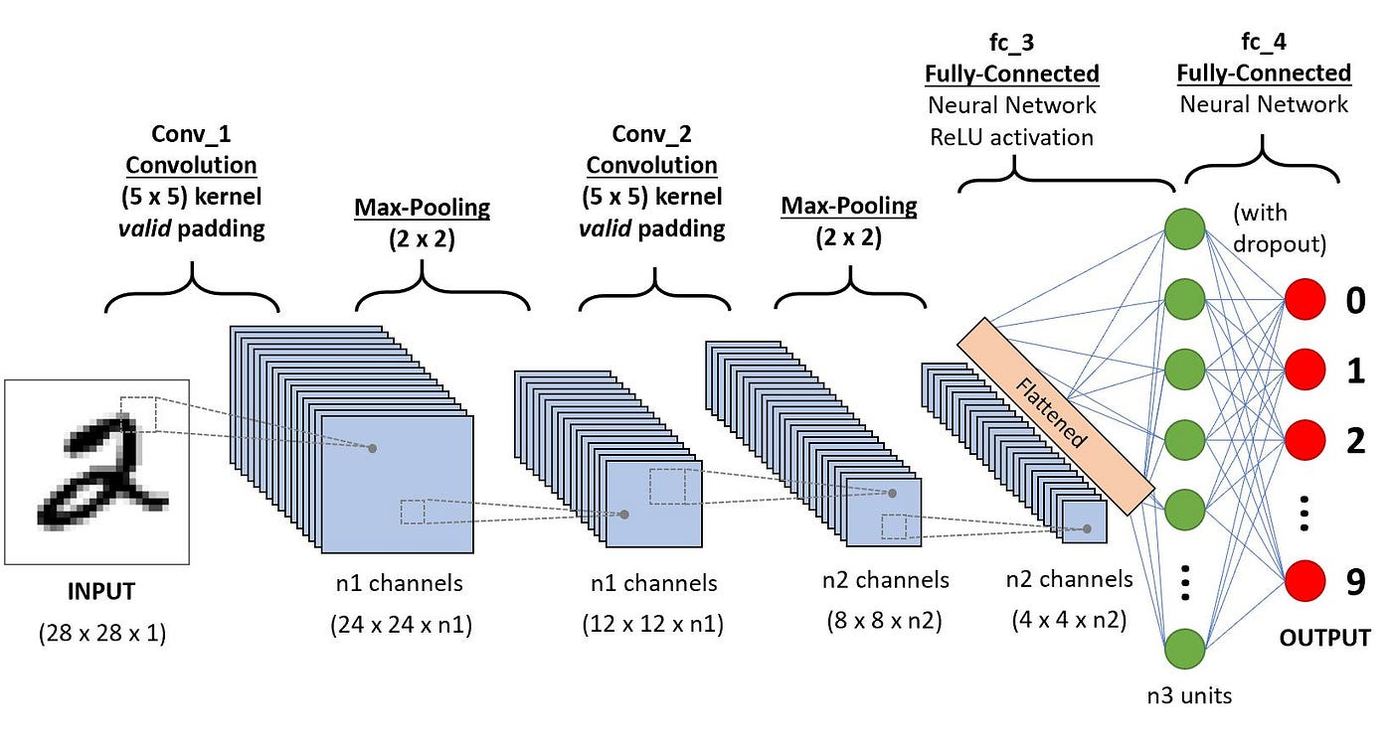

<https://adamharley.com/nn_vis/mlp/3d.html>

### Applications in Computer Vision

The applications of CNNs in computer vision are far-reaching. Facial recognition, a challenging task due to variations in facial expressions, lighting conditions, and orientations, benefits significantly from the hierarchical feature extraction capabilities of CNNs. The network can automatically learn and discern unique facial features, enabling accurate and robust recognition.

In the realm of autonomous vehicles, CNNs play a pivotal role in tasks like object detection and lane recognition. The ability to extract hierarchical features allows these networks to interpret the visual environment, identifying objects, pedestrians, and road boundaries.

Medical imaging stands as another domain where CNNs have demonstrated remarkable effectiveness. Tasks such as tumor detection in radiological images or cell classification in pathology slides benefit from the network's capacity to automatically learn and recognize intricate patterns indicative of specific conditions.

### The Power of Transfer Learning

One noteworthy aspect of CNNs is their adaptability and the concept of transfer learning. In scenarios where labeled data might be scarce or training a CNN from scratch is resource-intensive, transfer learning allows practitioners to leverage pre-trained models. These models, trained on extensive datasets for generic visual tasks, can be fine-tuned for domain-specific applications. This approach significantly accelerates the model development process and enhances performance, especially in niche domains.

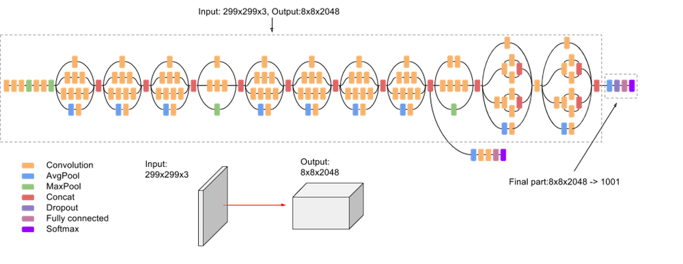

A Comprehensive Guide to Convolutional Neural Networks: <https://towardsdatascience.com/a-comprehensive-guide-to-convolutional-neural-networks-the-eli5-way-3bd2b1164a53>

<https://distill.pub/2018/building-blocks/>

## Recurrent Neural Networks (RNNs)

As we unravel the complexities of deep learning in Week 6, our focus shifts to Recurrent Neural Networks (RNNs), a class of neural networks designed to excel in tasks involving sequential data and context. RNNs stand as powerful tools, particularly in applications where understanding the temporal dependencies within sequences is paramount, such as natural language processing, speech recognition, and time series analysis.

### Temporal Dynamics

At the core of RNNs lies the capacity to maintain memory across sequences, a crucial feature that sets them apart in handling sequential data. Traditional neural networks process each input independently, lacking the ability to consider the order or context of the data. RNNs, on the other hand, introduce recurrent connections, allowing them to maintain a hidden state that captures information from previous inputs. This inherent memory mechanism enables RNNs to recognize patterns that unfold over time, making them particularly effective in tasks where understanding the sequence is essential.

### Applications in Natural Language Processing

In natural language processing (NLP), understanding the context and sequence of words is fundamental for tasks like language modeling, sentiment analysis, and machine translation. RNNs shine in these scenarios by considering the sequential nature of language. The ability to capture dependencies between words and understand the context in which they appear allows RNNs to generate coherent and contextually relevant outputs.

For instance, in machine translation, where the translation of a sentence depends on the preceding words, RNNs prove invaluable. The network's recurrent connections enable it to remember the context of the sentence as it translates, ensuring that the output is not only accurate in terms of individual words but also coherent in the context of the entire sentence.

### Speech Recognition

Speech recognition tasks involve processing sequences of audio data, where the context and order of phonemes and words are critical. RNNs, with their ability to capture temporal patterns and dependencies, excel in this domain. By maintaining memory across the sequence of audio frames, RNNs can discern subtle nuances in speech, making them robust in recognizing spoken language even in varied accents and intonations.

### 

### Time Series Analysis

In time series analysis, where the goal is to predict future values based on past observations, RNNs offer a compelling solution. Whether it's predicting stock prices, weather patterns, or energy consumption, RNNs leverage their recurrent connections to capture the temporal dependencies inherent in sequential data. The network learns patterns in the time series, allowing it to make informed predictions about future values.

### Challenges and Advancements

While RNNs excel in capturing short-term dependencies within sequences, they face challenges in maintaining information over longer sequences, often referred to as the "vanishing gradient" problem. To address this, more advanced variants like Long Short-Term Memory (LSTM) networks and Gated Recurrent Unit (GRU) networks have been developed. These architectures introduce gating mechanisms that regulate the flow of information, allowing RNNs to capture and propagate relevant information over extended sequences.

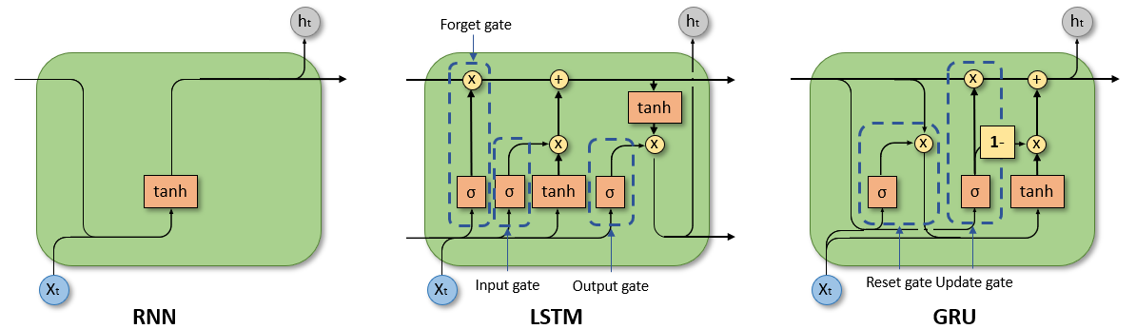

RNNs vs LSTMs vs GRUs: <https://medium.com/analytics-vidhya/rnn-vs-gru-vs-lstm-863b0b7b1573>

## Conclusion:

As we culminate our exploration of deep learning in Week 6, the profound impact and versatility of this field become ever more apparent. Neural networks, with their brain-inspired structures and intricate layers, have ushered in a new era of machine learning. The hierarchical nature of these networks, coupled with their depth, enables them to autonomously learn and represent complex features from vast arrays of data. This capability is not just theoretical but has tangible impacts across various domains, from image recognition to natural language processing.

Looking ahead, the future of deep learning appears both promising and challenging. The power of transfer learning, the potential of unsupervised learning, and the continuous quest for more efficient and effective network architectures suggest a landscape ripe with innovation and discovery. Yet, this journey also comes with its share of challenges—data privacy concerns, ethical implications, and the need for more interpretable models.